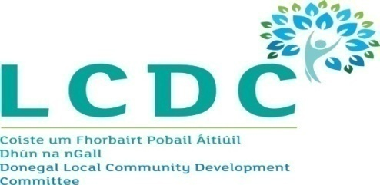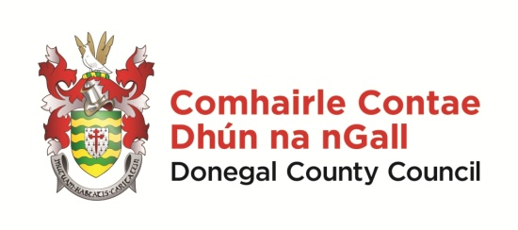

Draft Minutes of Donegal Local Community Development Committee
County House, Lifford, 2.30pm on 17th April 2018

Members | Clr Martin McDermott (Chair), Seamus Neely, Martin McBride, Clr Niamh Kennedy, Clr Maire Therese Gallagher, Jim Slevin, Susan McCauley, Anne McHugh, Peter Walker, Susan McLaughlin, Micheal Mac Giolla Easbuig, Liam McElhinney and Michael Tunney
Apologies | Paul Hannigan, Aengus Kennedy, Maire Ui Maolin, Fionnan Bradley, James O Donnell & Siobhan McLaughlin
Chief Officer | Paddy Doherty
Attending | Liam Ward, Eimear McDermott, Adrienne Kelly & Kathleen Browne

Welcome

Clr Martin McDermott, Chairperson, welcomed everyone and thanked the members present for attending the meeting.

- Minutes of Previous Meeting
Draft minutes of the LCDC meeting of 20th March 2018 were considered. The minutes were proposed by Martin McBride and seconded by Clr Marie Therese Gallagher.

- Healthy Ireland Fund
Eimear McDermott reviewed the details of the award of funding to the joint application by Donegal LCDC and CYPSC under the Healthy Ireland Fund. She advised members that on 23rd March Pobal had offered an extension of 3 months to the timeline for the scheme. Whilst Donegal LCDC were on target in relation to the award of funding and expenditure of same for the 10 Actions of their plan, it was decided to seek an extension of one month, to 30th April 2018, to give them more time to complete all the necessary paperwork.

The application for extension was signed off by the Chief Executive, Donegal County Council and Chief Officer, Donegal LCDC. Eimear advised members that the approval of the Donegal LCDC for this request for extension was also required. On the proposal of Martin McBride, seconded by Clr Maire Therese Gallagher, members noted and approved the application for extension of the Health Ireland Fund until 30th April 2018.

- Healthy Ireland Fund Sub Committee
Eimear McDermott advised members that following the selection of LCDC Representatives onto the Healthy Ireland Fund Sub Committee at the March Meeting, it was hoped that the two HSE Representatives on this Committee would be selected shortly.

Eimear also advised that it was confirmed that further funding under the Healthy Ireland Fund would be available in 2018. In this regard, Pobal were holding an information event on 1st May 2018. It was agreed that information in relation to this event would be circulated to members of the Sub Committee.

- Sub Committees of Donegal LCDC
Paddy Doherty advised that arising from the discussion at the March LCDC meeting a list of the various Sub Committees of the LCDC had been circulated to members for noting/information purposes.

Clr Maire Therese Gallagher queried the role of the LCDC if Sub Committees were set up for assessment/award of funding for each funding stream. Paddy Doherty advised that the consensus nationally was that the assessment/award of the funding at Sub Committees level with final approval by the LCDC was best practise.

Paddy confirmed that the role of the full LCDC was the implementation of the LECP and the community aspects of it. He advised that the Monitoring and Evaluation Sub Committee reported on the input of the various sectors, represented on the LCDC, into the LECP regularly.

Clr Martin McDermott advised that nationally due to difficulties encountered by some LCDC’s the emphasis was on Sub Committees to progress projects and funding streams. Clr Maire Therese Gallagher suggested that one Sub Committee be appointed to cover the assessment and award of funding from the various funding streams.

It was agreed that an update from the Monitoring and Evaluation Sub Committee would be presented at the next LCDC Meeting.

- Vote of Sympathy
Members expressed their condolences to Susan McLaughlin and Clr Martin McDermott on their recent bereavements.

- Town & Village Renewal
Clr Martin McDermott queried the current position in relation to the projects awarded funding under the Town & Village Renewal programme in 2016 and 2017.

Paddy Doherty advised that contracts had been awarded for four of the projects and the contractors would be on site shortly. There was an issue with land access for the other projects.

Peter Walker raised the issue of support for groups in completing applications for funding to the correct standard. Members agreed that this was an issue for many new or smaller groups. Seamus Neely stated that it was a challenge for those assessing applications when groups did not present them to a good standard.

Following a discussion with members, it was agreed that events would be held in each Municpal District to advise groups on the general principles of completing an application for funding. It was agreed that the best mechanism for delivery of these events would be examined and a report and recommendation would be brought to members.

- Next Meeting
It was agreed that the next meeting of the LCDC would be held on 14th May 2018 at 2.00 pm

This concluded the business of the meeting

